AWS Student Builder Group-MLRIT
MLRIT Main Website – Club Page Content Submission

Official Club Name
AWS Student Builder Group – a student-driven technical community at MLR Institute of Technology focused on AWS Cloud and emerging technologies

Updated Club Logo
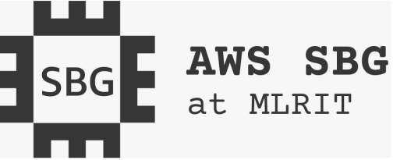

Vision / Tagline

“Learn. Build. Explore. Grow with AWS Cloud.”
The AWS Student Builder Group aims to create an active student community where members can learn emerging technologies, gain practical experience, connect with others, and build skills for future opportunities in the technology industry

About the Club

The AWS Student Builder Group is a student-driven community where students get to explore AWS Cloud and other emerging technologies beyond what they learn in the classroom. It gives students a chance to learn by doing and gain practical experience.The group focuses on areas such as Cloud Computing, Artificial Intelligence, Machine Learning, Generative AI, DevOps, Serverless Computing, and Cybersecurity.
Through workshops, technical sessions, projects, hackathons, and coding challenges, students can improve their technical skills, problem-solving abilities, teamwork, communication, and leadership.

What makes the group unique?

What makes the AWS Student Builders Group unique is that it goes beyond simply learning about cloud technology. It gives students a platform to learn through hands on workshops, real world projects, hackathons, and practical challenges while exploring areas such as AWS Cloud, AI, DevOps, Serverless, Security, and Generative AI. Students can build meaningful projects, earn verifiable AWS digital badges and industry recognized credentials, connect with AWS experts and a global student community, and develop both technical and leadership skills. The group creates an environment where students can learn, build, collaborate, and grow while gaining experiences that can strengthen their portfolios and support their future internship and placement opportunities.

Purpose of the Club

The AWS Student Builder Group gives students a space to learn, explore, and work with cloud and emerging technologies beyond the classroom. The group focuses on practical learning, collaboration, and helping students gain experience by building projects, participating in workshops, and exploring real world applications of AWS technologies.

Key Objectives
• Help students build a strong foundation in AWS and Cloud Computing through regular learning activities and hands on practice.
• Encourage learning by doing through projects, workshops, labs, hackathons, and technical challenges.
• Give students opportunities to explore their ideas, experiment with AWS services, and build useful cloud based solutions.
• Encourage students to learn from and work with each other through teamwork, collaboration, and knowledge sharing.
• Help students explore emerging technologies such as AI, Generative AI, DevOps, Serverless Computing, and Cloud Security.
• Connect students with mentors, AWS experts, and industry professionals to help them understand real world practices and career opportunities.
• Support students in building projects, earning relevant credentials, and developing skills that can help with internships, placements, and future opportunities.

Activities & What Happens in the Club

The AWS Student Builder Group conducts various technical activities throughout the year to help students learn new technologies, gain practical experience, improve their skills, and work together on real world challenges.

Technical Workshops & Training

AWS Cloud and Cloud Computing

Artificial Intelligence and Machine Learning

Generative AI

DevOps and Serverless Computing

Cybersecurity

Other emerging technologies

These sessions focus on practical learning, allowing students to understand concepts and gain experience using industry relevant tools and technologies.

Hands-on Labs & Cloud Activities

Students get opportunities to work with AWS services through guided labs and practical activities. These sessions help students understand how cloud resources are managed, applications are deployed, and AWS services are used to build real world solutions.

Hackathons & Technical Competitions

The group encourages students to participate in hackathons, coding challenges, and other technical competitions. These activities help students apply what they learn, improve problem solving skills, and work effectively as a team.

Innovation & Project Development

The AWS Student Builder Group encourages students to turn their ideas into practical projects using AWS technologies. Students can work on cloud based applications and solutions while gaining experience in planning, development, deployment, and problem solving.

AWS Learning Sessions

The group can organize peer learning sessions where students share their knowledge and experiences with fellow members. Seniors and students with experience in AWS can help others understand cloud concepts, tools, and technologies in a simple and practical way.

Career & Industry Exposure

The group provides opportunities for students to learn about industry practices, career paths, internships, and certifications through expert sessions, AWS community events, and interactions with professionals. These activities help students understand what is expected in the technology industry and prepare for future opportunities.

Knowledge Sharing & Community Learning

Learning within the group is not limited to workshops. Students are encouraged to share resources, discuss technologies, work together on projects, and help each other solve technical problems. This creates a collaborative environment where students can learn and grow together.

Events Conducted

AWS Cloud Trek Workshop

The AWS Cloud Trek Workshop was a two day hands on workshop conducted on 17th and 18th October 2025. The workshop introduced students to cloud computing and AWS services such as Amazon S3 and Amazon EC2. Students gained practical experience in cloud resource management, application deployment, hosting, and security configurations.

AWS Community Day – ZENITH'25: Cloud Voyage

As part of ZENITH'25 – Cloud Voyage, AWS Community Day was conducted at MLR Institute of Technology in December 2025. The event brought together students, AWS speakers, industry experts, and cloud professionals. Through technical sessions and interactive discussions, students gained insights into cloud technologies, modern infrastructure, industry practices, and career opportunities.

8.Events to Be Conducted

Major events planned by the club (tentative calendar for Academic Year 2026–2027):
Event Name | Date | Target Participants
AWS cloud trek | September | 2nd&3rd Year Students
AWS Student community day 2026 Edition | 17th December | All 4 Years
Online sessions on AWS services | Every month | All 4 years

Flagship / Star Events
  - AWS student community day
  - AWS cloud trek

9.Event Photos & Videos
1.AWS Cloud trek
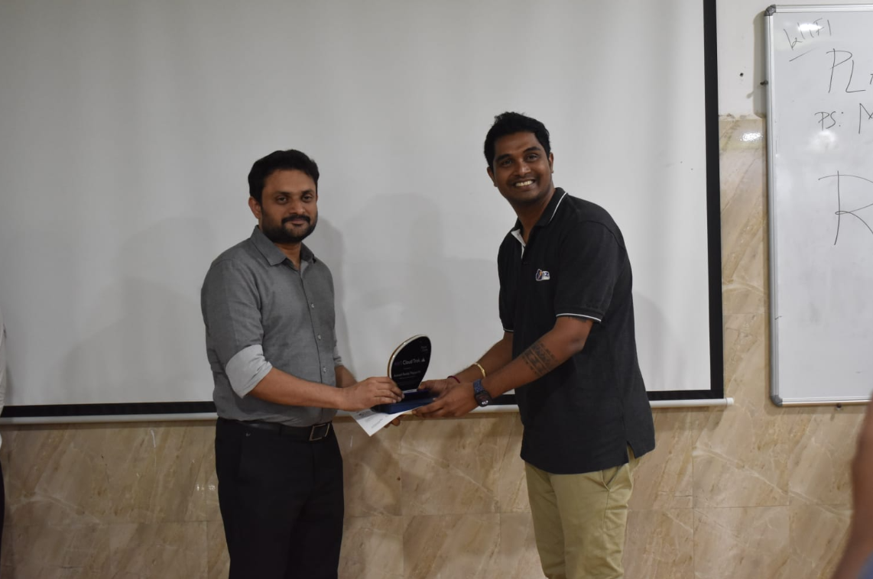
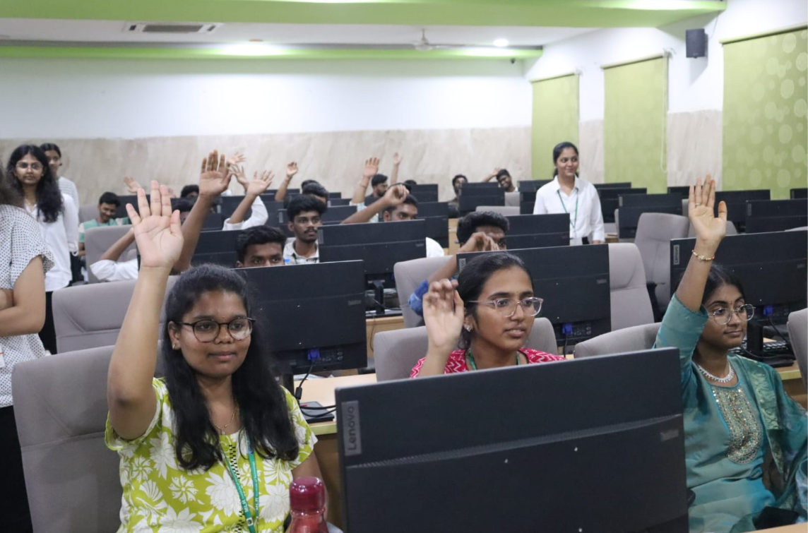

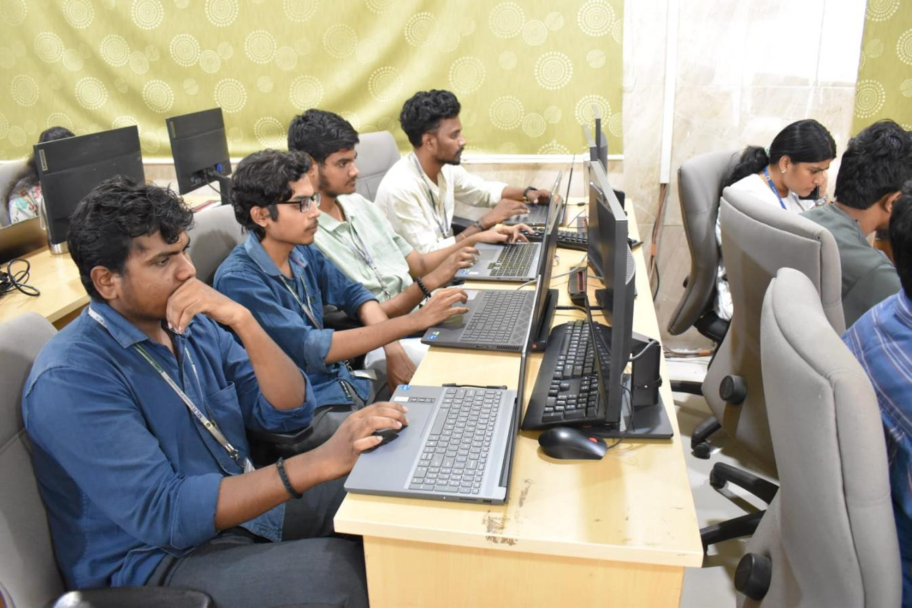

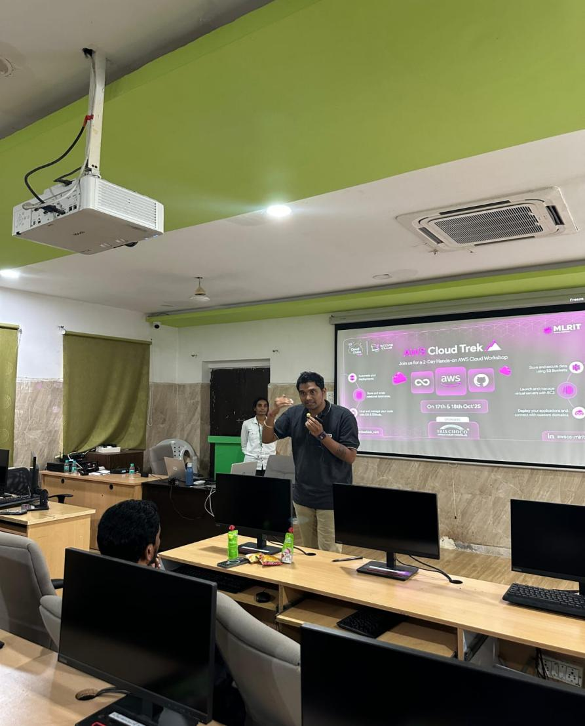

- AWS student community day

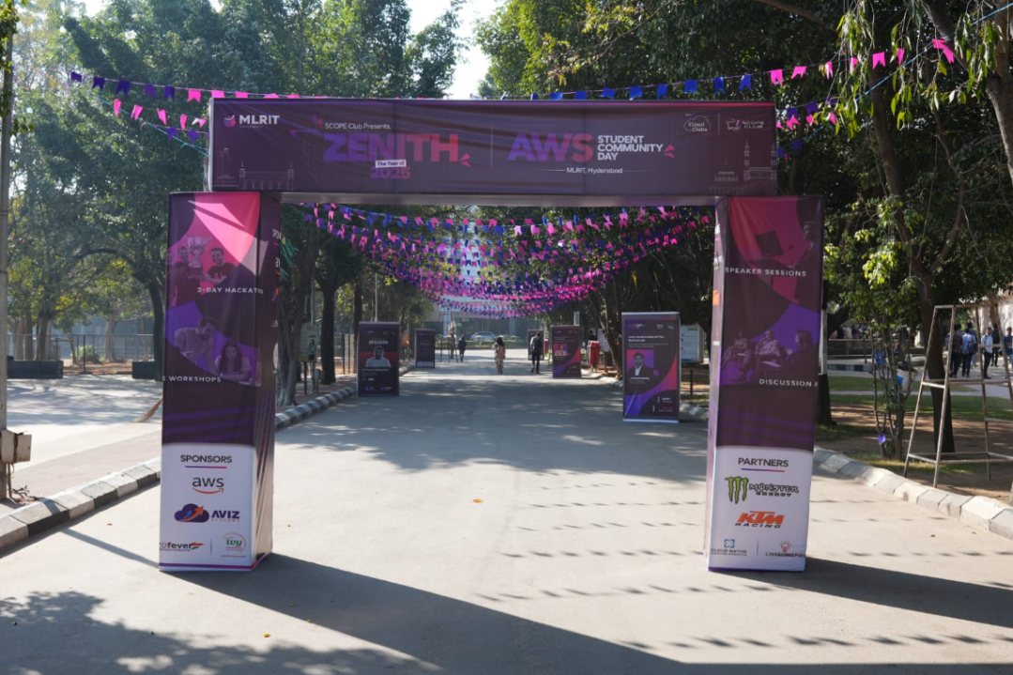
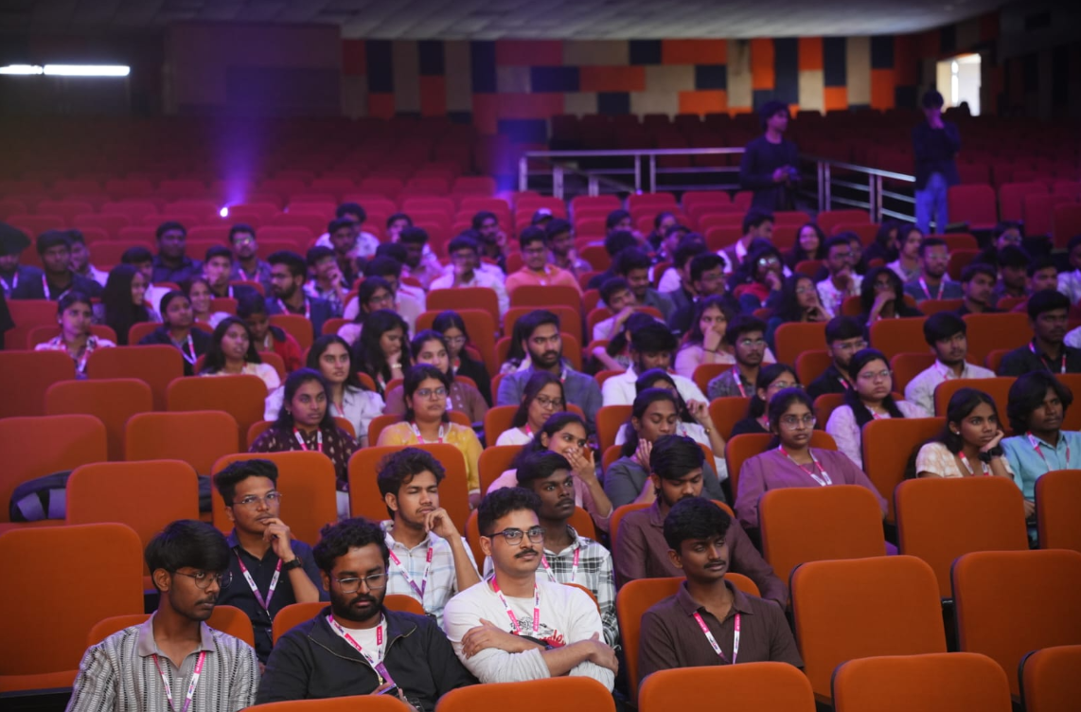

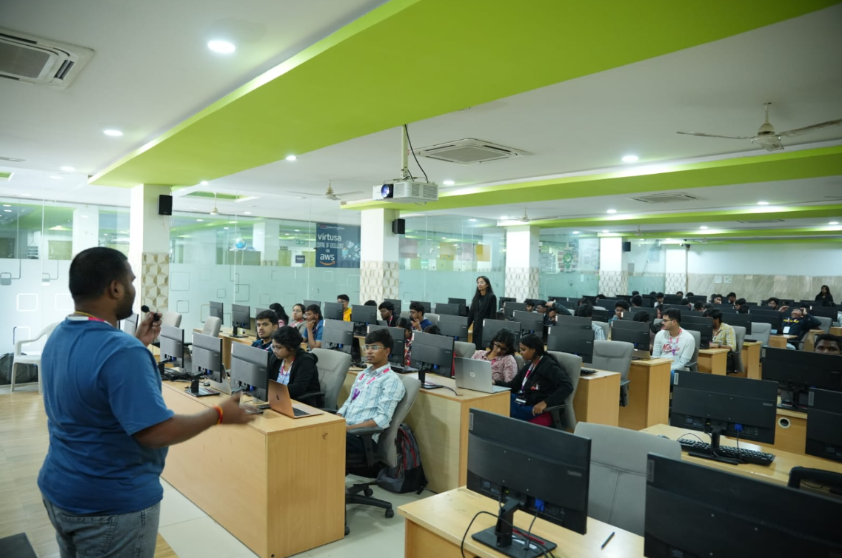
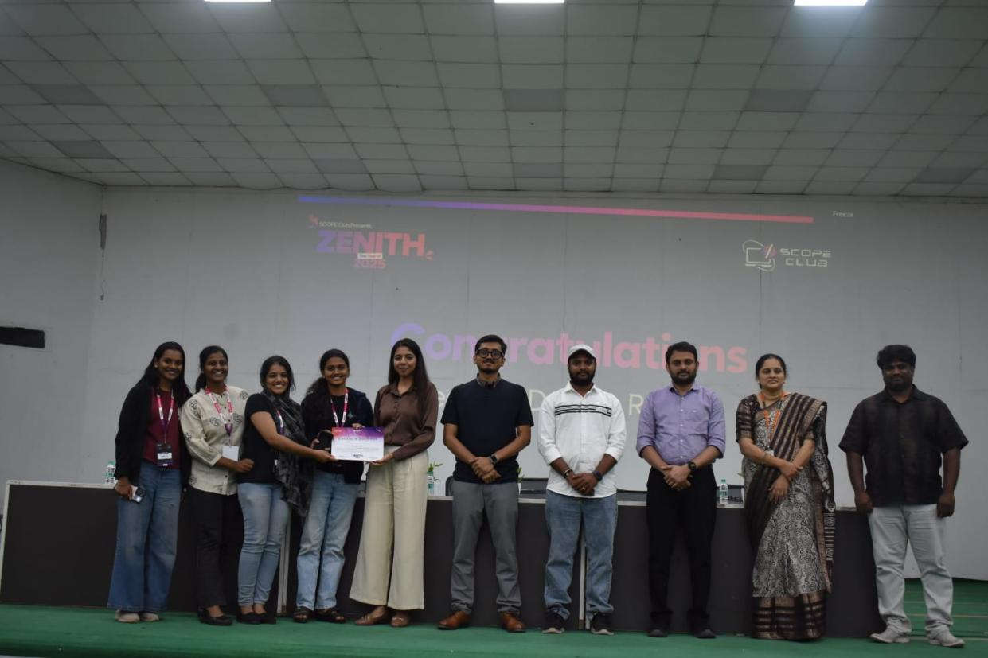

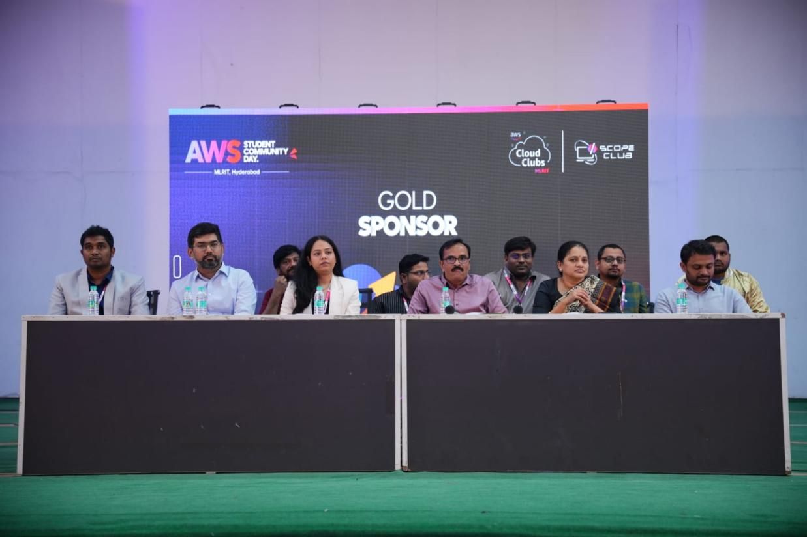

10.Club Website / Online Presence

Instagram: awssbg_mlrit
LinkedIn: AWSSBG MLRIT
Individual Club Website:AWS SBG at Mlr Institute of Technology | Meetup

